Scooptram XYWJ-5
Technical specification
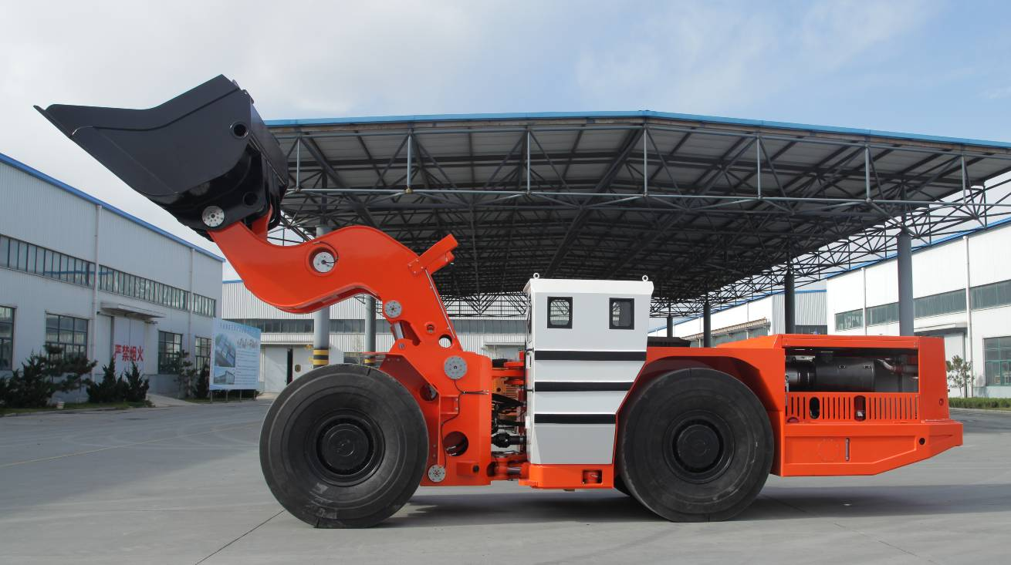
The Diesel Scooptram is capacity of 10 tons. It’s driven by Mercedes Benz Engine OM926LA, improves productivity and underground tunnel, and reduces the pollution efficiently.

Characteristics

Structure
1. Z-bar device
2. Lockup for boom & steering
3.V shape bucket

Safe Operation
1.SAHR brake system
2.ROPS/FOPS Certificate

Comfortable Operation
1. Ergonomics Canopy with generous operation room,
2. Enclosed canopy with air conditioner
3. Noise ≤85db
4. Adjustable operator’s seat
Efficient Production
- Matched Powertrain
- Digital Monitor & diagnose
- Lube Layout to maintain
Main Technical Parameter
主要技术参数

Bucket motion times
工作时间
Raising Time:  举臂时间: | 9.6s
Lowering Time:  落臂时间: | 6.6s
Tipping Time:  翻斗时间: | 3.3s
Max. Lifting Height:  最大举升时的整机高度: | 5284mm
Max. Discharging Height:  最大卸载高度: | 1700mm
Bucket pivot at Max. lifting:  最大举升时的铰销高度: | 3410mm
Min. Discharging Distance:  最小卸载距离: | 1816mm
Discharging Angle:  最大卸载角度: | 42°
Wheel Base:  轴距: | 3600mm
Leaving Angle:  离去角: | 15°
Rear Axle Oscillation Angle:  后桥摆动角: | ±8°
Min. Off-ground Clearance:  最小离地间隙: | 358mm
Max. gradeability:  爬坡能力: | 25%
Max. Steering Angle:  最大转向角: | ± 42 °
Dimension (tramming):  外形尺寸（运输状态） | 9880mm×2525mm×2500mm
Bucket Capacity(SAE):  铲斗容量(SAE) | 5m³
Weights
重量
Operating Weight:  操作重量: | 27500 kg
Rated Loading Capacity:  额定载重量: | 10000 kg
Axle weights without load
空载
Front Axle:  前桥载荷: | 12500kg
Rear Axle:  后桥载荷: | 15000kg
Axle weights with load
满载
Front Axle:  前桥载荷: | 26000kg
Rear Axle:  后桥载荷: | 11500kg
Driving Speeds Forward and Reverse
运行能力
First Gear:  1档: | 0~4.2km/h
Second Gear:  2档: | 0~8.5km/h
Third Gear:  3档: | 0~16.5km/h
Forth Gear:  4档: | 0~28.0km/h
Min. Steering Radius
最小转向半径
Outer / Inner:  外侧 / 内侧: | 6600mm/3560mm

Main Configuration
主要配置

Diesel Engine
发动机
Manufacturer:  制造厂: | Mercedes Benz  梅赛德斯奔驰
Model:  型号: | OM926 LA
Rated Power:  额定功率: | 240KW@2200 rpm
Features:  特点: | Water Cooled, Turbo Charged  水冷, 增压
Hydraulic Torque Converter
液力变矩器
Manufacture:  制造厂: | DANA  美国德纳
Model:  型号: | C5000 Series
Power Shift Transmission
变速箱
Manufacture:  制造厂: | DANA  美国德纳
Model:  型号: | R36000 Series
Features:  特 点: | 前/后四档 电子控制  F4/R4 Electronic control
Drive Axle
驱动桥
Manufacture:  制造厂: | KESSLER  德国凯斯勒
Model:  型号: | D101
Tyres
轮胎
Manufacture:  制造厂: | China Tyres Company  中国轮胎
Model:  型号: | 18.00-25
Hydraulic System
液压系统
Components:  组成: | Servicing system, steering system, braking system, fill oil system  工作系统、转向系统、 制动系统 、补油系统
Features:  特 点: | Service and steering hydraulic systems are equipped with PARKER Hydraulic Pumps and Valves, and brake hydraulic system equipped with Mico hydraulic components.  The oil flow from steering hydraulic pump is directed to bucket hydraulics when steering is not used.  Rated Pressure of service hydraulics: 19Mpa  液压泵和阀采用派克品牌，制动系统液压元件采用米肯品牌。  采用双泵合流，减少能量损失。工作系统压力19Mpa
Braking System
制动系统
Components:  组 成: | Service/Parking/Emergency brake  工作制动、停车制动和紧急制动
Features:  特 点: | These brakes are spring applied, hydraulically released type (SAHR)，with fully enclosed, multiple wet discs that are forced-cooled at each wheel end.  工作制动、停车制动为弹簧制动，液压释放.  制动器为全封闭液压湿式多盘制动器

Electric System
电器系统
Alternator:  发电机: | 28V 100A
Batteries:  蓄电池: | 12VX2 165Ah
Lights:  工作灯: | Front: 5 pcs  Rear: 3 pcs
Sensors:  传感器: | Fuel/Oil level sensors, Sensors of service, steering, brake system, Limit Sensor  柴油、液压油油位传感器，工作、转向、制动系统压力传感器，限位传感器
Alarm:  报警提示: | Red/green indicators  红绿指示灯  Rotation Warning Lamp  旋转报警灯  Low oil level warning/Oil pressure warning  低油位报警/油压报警
Monitor Screen:  显示器: | IFM CR1083 7” LED
Controller:  控制器: | IFM CR2532 CPU 50MHz
Cab
驾驶室
Features:  特点: | - ROPS/FOPS approved  符合ROPS/FOPS标准  - Side Seated operator for bi-directional operation  驾驶员侧坐以便双向操作  - Adjustable Spring Cushioned Seat with Three Points Belt  可调弹簧减震座椅配安全带
Optional equipment
可选配置
Lincoln auto lube with timer
林肯润滑系统
Ansul Checkfire, autofire suppression
安索集中灭火系统
Fully Enclosed Cab with Air Conditioner
全封闭空调驾驶室
Customized Bucket Capacity
可定制其他斗容

