Scooptram XYWJ-8.5
Technical specification
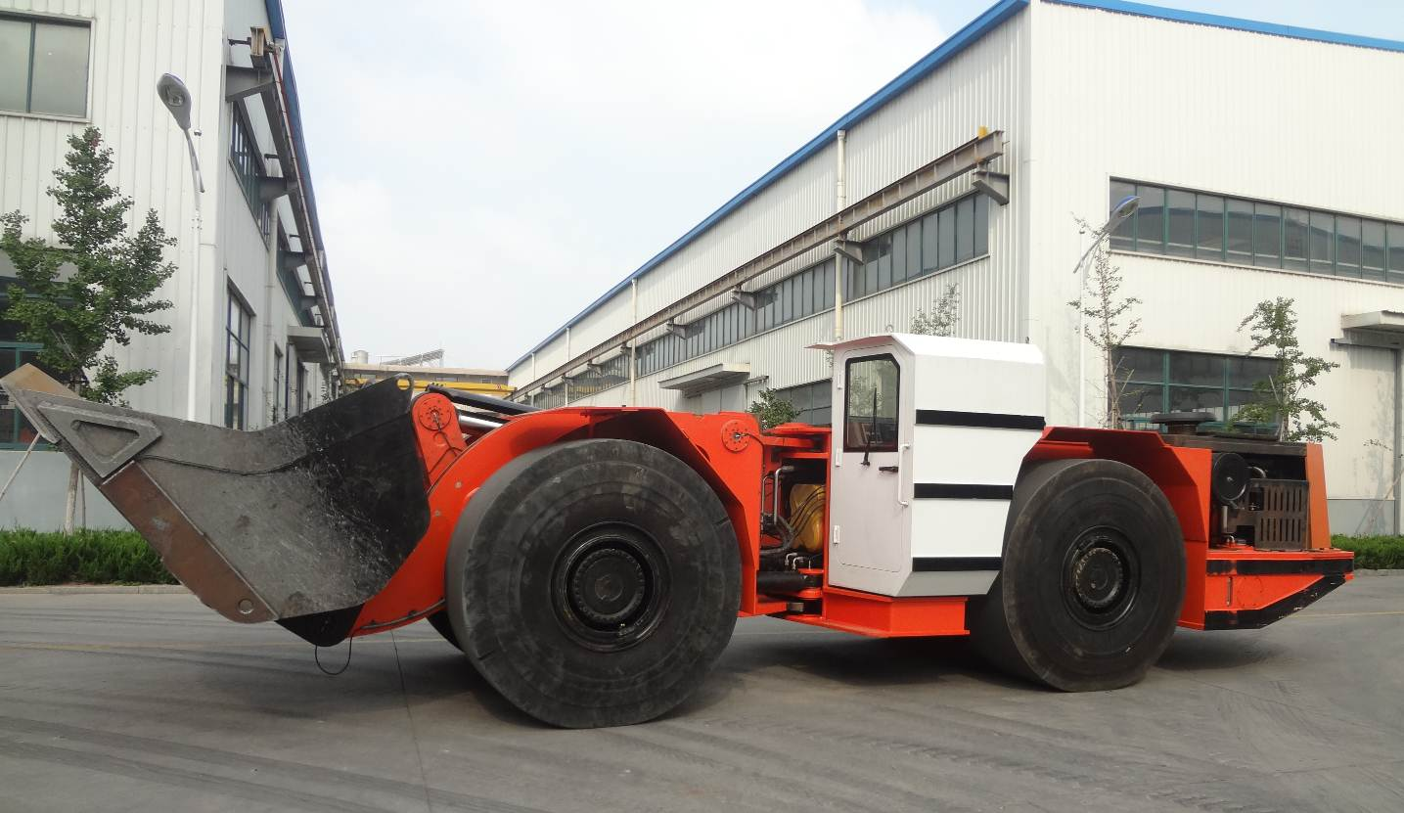
The Diesel Scooptram is capacity of 16 tons. It’s driven by Mercedes Benz Diesel Engine OM502LA, improves productivity and underground tunnel, and reduces the pollution efficiently.

Characteristics

Structure
1. Z-bar device
2. Lockup for boom & steering
3.V shape bucket

Safe Operation
1.SAHR brake system
2.ROPS/FOPS Certificate

Comfortable Operation
1. Ergonomics Canopy with generous operation room,
2. Enclosed canopy with air conditioner
3. Noise ≤85db
4. Adjustable operator’s seat
Efficient Production
- Matched Powertrain
- Digital Monitor & diagnose
- Lube Layout to maintain

Main Technical Parameter

Bucket motion times
Raising Time: | 7.3s
Dropping Time: | 4.0s
Tipping Time: | 3.0s
Max. Lifting Height: | 6800mm
Max. Discharging Height: | 2750mm
Bucket pivot at Max. lifting: | 4600mm
Min. Discharging Distance: | 1850mm
Discharging Angle: | 40°
Wheel Base: | 3860mm
Leaving Angle: | 14°
Rear Axle Oscillation Angle: | ±8°
Min. Off-ground Clearance: | 500mm
Max. gradeability: | 25%
Max. Steering Angle: | ± 42 °
Dimension (tramming): | 11280mm×3100mm×2800mm
Bucket Capacity(SAE): | 8m³
Weights
Operating Weight: | 47000 kg
RatedLoading: Capacity: | 16000 kg
Axle weights without load
Front Axle: | 20500 kg
Rear Axle: | 26500 kg
Axle weights with load:
Front Axle: | 44500 kg
Rear Axle: | 19500 kg
Driving Speeds Forward and Reverse
First Gear: | 0~6.8 km/h
Second Gear: | 0~11.4 km/h
Third Gear: | 0~19.0 km/h
Forth Gear: | 0~27.1 km/h
Min. Steering Radius
Outer / Inner: | 7350 mm/3460 mm

Main Configuration
Hydraulic System
Components: | Servicing system, steering system, braking system, fill oil system
Features: | The hydraulic system use PARKER’s hydraulic pumps and valves. The braking system use MICO’s hydraulic components.  Using the method of dual pumps confluence, in order to reduce the energy loss.  Rated Pressure of service hydraulics: 28Mpa
Braking System
Components: | Service/Parking/Emergency brake
Features: | These brakes are spring applied, hydraulically released type (SAHR)，with fully enclosed, multiple wet discs that are forced-cooled at each wheel end.  Equiped with a hand pump to release the brake in emergency
Diesel Engine
Manufacturer: | Mercedes Benz
Model: | OM460LA
Rated Power: | 315KW@1800rpm
Features: | Water Cooled, Turbo Charged  Catalytic fume purifier
Hydraulic Torque Converter
Manufacture: | DANA
Model: | C9000 Series
Power Shift Transmission
Manufacture: | DANA
Model: | 6000 Series
Features: | F4/R4 Electronic control  Modulation
Drive Axle
Manufacture: | KESSLER
Model: | D106
Tyres
Manufacture: | China Tyres Company
Model: | 29.5x29 L5S

Electric System
Alternator: | 28V 100A
Batteries: | 12VX2 195Ah
Lights: | Front: 5 pcs  Rear: 4 pcs
Reverse Alarm | YES
Sensors: | Fuel/Oil level sensors, Sensors of service, steering, brake system, Limit Sensor
Alarm: | - Red/green indicators  - Rotation Warning Lamp  - Low oil level warning/Oil pressure warning  - Engine failure Warning
Monitor Screen: | IFM CR1083 7” LED
Controller: | IFM CR2532 CPU 50MHz
Cab
Features: | - ROPS/FOPS approved  - Side Seated operator for bi-directional operation  - Adjustable Spring Cushioned Seat with Three Points Contact Seat Belt  - Cab is removable independently
Fuel & Lubricant Specifications
Diesel Fuel: ASTM D975 Grade 2D
Engine Oil: SAE 15W-40
Hydraulic Oil: ISO VG 46
Transmission Fluid: SAE 30
Optional equipment
Lincoln auto lube with timer
Ansul Checkfire, autofire suppression
Fully Enclosed Cab with Air Conditioner
Customized Bucket Capacity

SAFETY
- Neutral Brake
- Brake automatically apply when engine stoped
- Automatically open cabin door braking
- Brake automatically apply with low hydraulic oil level or low fuel level
- Brake automatically applies with low accumulator pressure.
- Reflective bands on front, rear and both sides of the vehicle.
- Wheel stop blocks

