Scooptram XYWJ-8.5
Technical specification
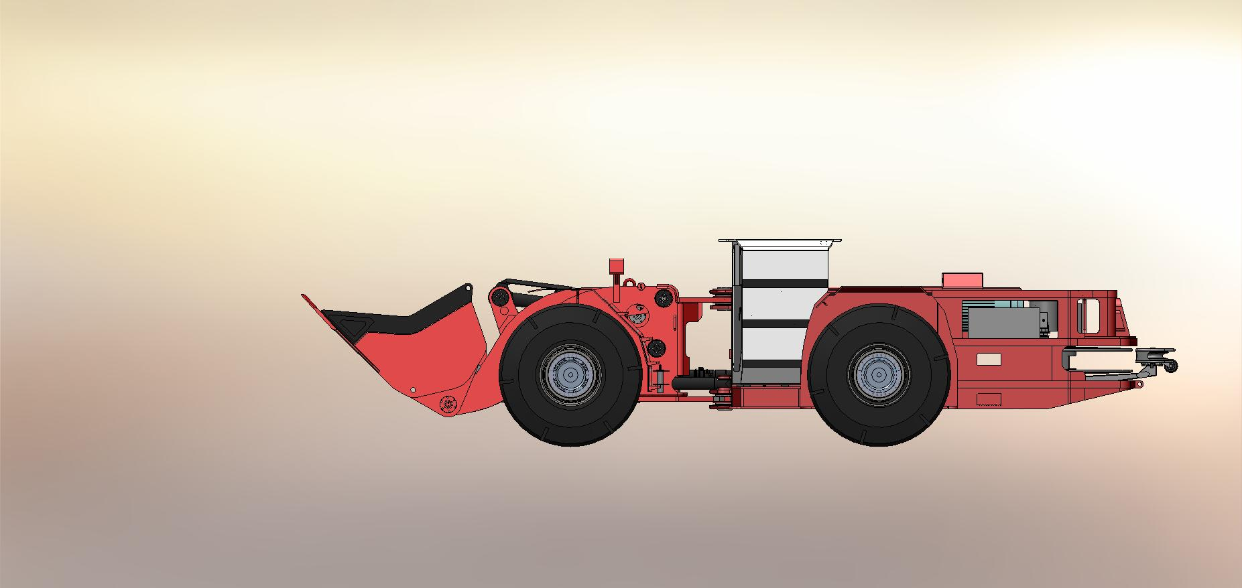

The Electric Scooptram is capacity of 17 tons. It’s driven by electric motor, improves productivity and underground tunnel, and reduces the pollution efficiently.

Characteristics

Structure
1. Boom with Z-bar Linkage
2. Horizontal Cable roller
3. Lockup for boom & steering
4.Cable length 350m
Safe Operation
1.SAHR brake system
2.ROPS/FOPS Certificate

Comfortable Operation
1. Ergonomics Canopy with generous operation room,
2. Enclosed canopy with air conditioner
3. Noise ≤85db
4. Adjustable operator’s seat
Efficient Production
- Matched Powertrain
- Digital Monitor & diagnose
- Lube Layout to maintain

Main Technical Parameter

Bucket motion times
Raising Time: | 7.3s
Dropping Time: | 4.0s
Tipping Time: | 3.0s
Max. Lifting Height: | 6800mm
Max. Discharging Height: | 2750mm
Bucket pivot at Max. lifting: | 4600mm
Min. Discharging Distance: | 1850mm
Discharging Angle: | 40°
Wheel Base: | 3860mm
Leaving Angle: | 14°
Rear Axle Oscillation Angle: | ±8°
Min. Off-ground Clearance: | 500mm
Max. gradeability: | 25%
Max. Steering Angle: | ± 42 °
Dimension (tramming): | 11750mm×3100mm×2800mm
Bucket Capacity(SAE): | 7m³
Weights
Operating Weight: | 48000 kg
Rated Loading: Capacity: | 17000 kg
Axle weights without load
Front Axle: | 21000 kg
Rear Axle: | 27000 kg
Axle weights with load:
Front Axle: | 46000 kg
Rear Axle: | 19000 kg
Driving Speeds Forward and Reverse
First Gear: | 0~3.5 km/h
Second Gear: | 0~6.1 km/h
Third Gear: | 0~10.3 km/h
Forth Gear: | 0~17.7 km/h
Min. Steering Radius
Outer / Inner: | 7350 mm/3460 mm

Main Configuration
Hydraulic System
Components: | Servicing system, steering system, braking system, fill oil system
Features: | Service and steering hydraulic systems are equipped with PARKER Hydraulic Pumps and Valves, and brake hydraulic system equipped with Mico hydraulic components.  The oil flow from steering hydraulic pump is directed to bucket hydraulics when steering is not used.  Rated Pressure of service hydraulics: 28Mpa
Braking System
Components: | Service/Parking/Emergency brake
Features: | These brakes are spring applied, hydraulically released type (SAHR)，with fully enclosed, multiple wet discs that are forced-cooled at each wheel end.  Equiped with a hand pump to release the brake in emergency
Electric Motor
Type: | Three-phase, squirrel-cage motor
Model: | HM2-315L2-4
Power: | 160KW@1480rpm
Operating Voltage: | 1000V
Frequency: | 50 Hz
Hydraulic Torque Converter
Manufacture: | DANA
Model: | C9000 Series
Power Shift Transmission
Manufacture: | DANA
Model: | 6000 Series
Features: | F4/R4 Electronic control  Modulation
Drive Axle
Manufacture: | KESSLER
Model: | D106
Tyres
Manufacture: | China Tyres Company
Model: | 29.5x29 L5S

Electric System
Control Voltage | 24V
Lights: | Front: 5 pcs  Rear: 4 pcs
Reverse Alarm | YES
Sensors: | Fuel/Oil level sensors, Sensors of service, steering, brake system, Limit Sensor
Alarm: | - Red/green indicators  - Rotation Warning Lamp  - Low oil level warning/Oil pressure warning  - Engine failure Warning
Monitor Screen: | IFM CR1083 7” LED
Controller: | IFM CR2532 CPU 50MHz
Cab
Features: | - ROPS/FOPS approved  - Side Seated operator for bi-directional operation  - Adjustable Spring Cushioned Seat with Three Points Belt  - Cab is removable independently
Fuel & Lubricant Specifications
Hydraulic Oil: ISO VG 46
Transmission Fluid: SAE 30
Optional equipment
Lincoln auto lube with timer
Ansul Checkfire, autofire suppression
Fully Enclosed Cab with Air Conditioner
Customized Bucket Capacity

SAFETY
- Brake automatically applied in Neutral
- Brake automatically apply when engine shutdown
- Door Interlock
- Brake automatically apply with low hydraulic oil level or low fuel level
- Brake automatically applies with low accumulator pressure.
- Reflective bands on front, rear and both sides of the vehicle.
- Wheel stop blocks
- Gear Selector automatically to Neutral when machine fails in axle or hydraulic oil level low.

