Scooptram XYWJY-4
Technical specification
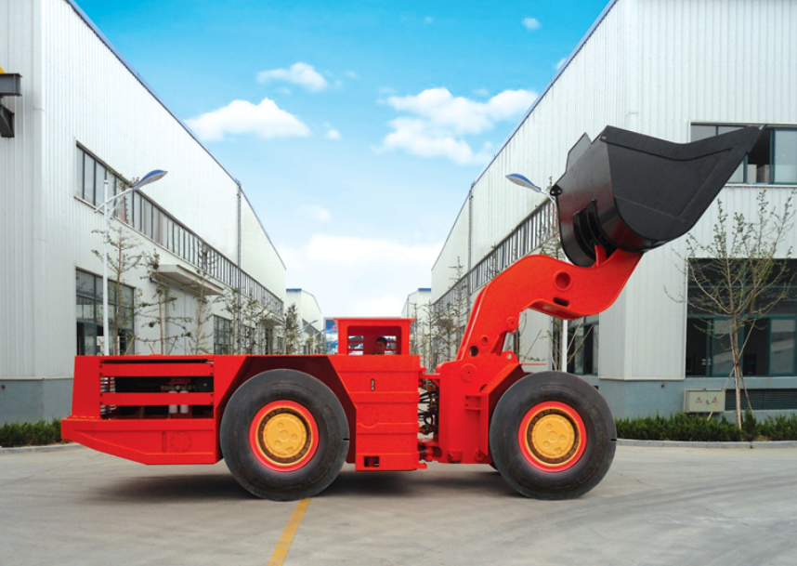
The 4 m³remote Scooptram is capacity of 10 tons. It’s driven by BF6M1015C Diesel Engine. It features powerful and high productivity. It can be shifted between remote and manual operation, and the remote distance is 180m, especially for underground dangerous circumstance.

Characteristics

Structure
1. Z-bar device
2. Lockup for boom & steering
3. V shape bucket

安全的工作环境
1.SAHR brake system
2.ROPS/FOPS Certificate
3.Remote Distance 180m
遥控功能齐全：
1. 7-way PWM signal, it can remote the operations of turning left/right, Lifting/lowering, bucket tipping /backing and accelerator.
2. 4-way digital signal input, change of remote/manual, run testing of brake, neutral and warning.

高效生产
- Matched Powertrain
- Lube Layout to maintain
Main Technical Parameter
主要技术参数

Bucket motion times
工作时间
Raising Time:  举臂时间: | 9.6s
Lowering Time:  落臂时间: | 5.37s
翻斗时间:  Tipping Time: | 2.5s
Max. Lifting Height  最大举升时的整机高度： | 5088mm
Max. Discharging Height  最大卸载高度： | 1805mm
最大举升时的铰销高度 | 3411mm
Min. Discharging Distance:  最小卸载距离： | 1660mm
Discharging Angle:  最大卸载角度： | 42°
Wheel Base:  轴距： | 3600mm
Leaving Angle:  离去角 | 15°
Rear Axle Oscillation Angle:  后桥摆动角： | ±8°
Min. Off-ground Clearance:  最小离地间隙： | 358mm
Max. gradeability:  爬坡能力： | 25%
Max. Steering Angle:  最大转向角： | ± 42 °
Dimension (tramming):  外形尺寸（运输状态） | 9800mm×2525mm×2500mm
Bucket Capacity(SAE 2:1Heaped):  铲斗容量(SAE堆装2:1) | 4m³
Weights:
重量：
Gross Weight:  设备重量： | 27500 kg
Rated Loading Operating Capacity:  额定载重量： | 8000 kg
Axle weights without load
空载
Front Axle:  前桥载荷 | 12500kg
Rear Axle:  后桥载荷 | 15000kg
Axle weights with load
满载
Front Axle:  前桥载荷 | 26000kg
Rear Axle:  后桥载荷 | 11500kg
Driving Speeds Forward and Reverse ：
运行能力：
First Gear:  1档 | 0~4.2km/h
Second Gear:  2档 | 0~8.5km/h
Third Gear:  3档 | 0~16.5km/h
Forth Gear:  4档 | 0~28.0km/h
Min. Steering Radius:
最小转向半径：
Outer / Inner  外侧 / 内侧 | 6600mm/3560mm

Main Configuration
主要配置

Diesel Engine
发动机：
Manufacturer:  制造厂： | DEUTZ  德国道依茨
Model:  型号： | BF6M1015C
Rated Power:  额定功率 | 223KW@2100 rpm
Features:  特点： | Water Cooled, Turbo Charged  水冷, 增压
Hydraulic Torque Converter:
液力变矩器：
Manufacture:  制造厂： | DANA  美国德纳
Model:  型号： | C5500 Series
Power Shift Transmission：
变速箱：
Manufacture:  制造厂： | DANA  美国德纳
Model:  型号： | R36000 Series
Features  特 点: | 前/后四档 电子控制
Drive Axle
驱动桥：
Manufacture:  制造厂： | DANA  德 纳
Type:  类型： | 前桥固定，后桥摆动±8°
Tyres
轮胎：
Manufacture:  制造厂： | China Tyres Company  中国轮胎
Model:  型号： | 18.00-25
Hydraulic System
液压系统：
Components:  组成： | Servicing system, steering system, braking system, fill oil system,  工作系统、转向系统、 制动系统 、补油系统
Features:  特 点: | Service and steering hydraulic systems are equipped with PARKER Hydraulic Pumps and Valves, and brake hydraulic system equipped with Mico hydraulic components.  The oil flow from steering hydraulic pump is directed to bucket hydraulics when steering is not used.  Rated Pressure of service hydraulics: 19Mpa  液压泵和阀采用派克品牌，制动系统液压元件采用米肯品牌。  采用双泵合流，减少能量损失。工作系统压力19Mpa
Braking System
制动系统
Components:  组 成: | Service/Parking/Emergency brake  工作制动、停车制动和紧急制动
Features:  特 点: | These brakes are spring applied, hydraulically released type (SAHR)，with fully enclosed, multiple wet discs that are forced-cooled at each wheel end.  工作制动、停车制动为弹簧制动，液压释放.  制动器为全封闭液压湿式多盘制动器

Electric System
电器系统
Alternator:  发电机 | 28V 80A
Batteries:  蓄电池 | 12VX2 165Ah
Starter:  启动马达 | 24V 6.5 KW
Lights:  工作灯 | Front:3 pcs  Rear:5 pcs
Alarm:  报警提示 | Rotation Warning Lamp旋转报警灯
Cab:
驾驶室：
Features:  特点： | - ROPS/FOPS approved  符合ROPS/FOPS标准  - Side Seated operator for bi-directional operation  驾驶员侧坐以便双向操作  - Adjustable Spring Cushioned Seat with Three Points Belt  可调弹簧减震座椅配安全带
Remote Control System
无线遥控系统
Vehicular unit  车载单元 | Volt：24VDC  Current：＜100mA  Wireless Communication Signal Frequency ：2.4GHz；  Communication Signal Transmission Speed：1Mbps；  Output of digital value, input of analog quantity and digital value expanded as required.
Remote Unit  遥控单元 | Volt工作电压：12.8VDC  Current工作电流：＜150mA  Wireless Communication Signal Frequency无线通信信号频率：2.4GHz；  Communication Signal Transmission Speed通信信号传输速率：1Mbps；  Battery电池规格：12.8VDC/1.4Ah Lithium iron phosphate battery磷酸铁锂电池  Input of analog quantity and LED display expanded as required.  可根据需要进行拓展模拟输入和  液晶显示等
Communication transmission 通信传输距离 | 40m~180m
Optional equipment:
可选配置：
Lincoln auto lube with timer:
林肯润滑系统
Ansul Checkfire, autofire suppression:
安索集中灭火系统
Fully Enclosed Cab with Air Conditioner
全封闭空调驾驶室
Customized bucket capacity
可定制其他斗容

