Underground Remote LHD XYWJY-1.5
Technical specification
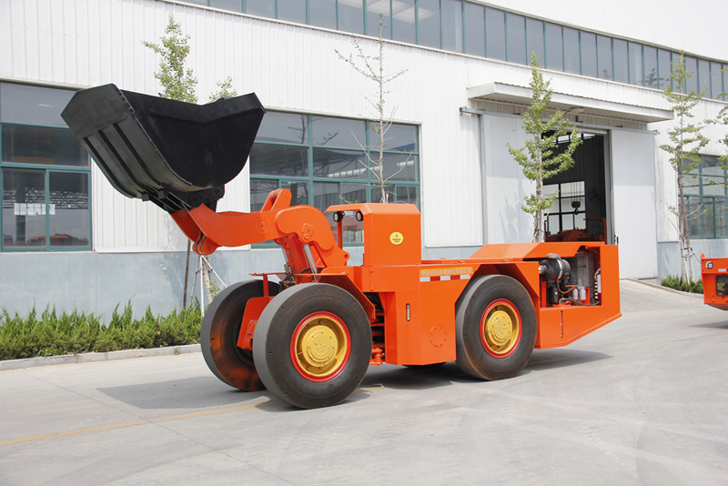
This remote LHD is capacity of 3.5 tons. It’s driven by Deutz Original Diesel Engine BF4M1013EC, equipped Visible Remote Control System. This LHD is special for dangerous and narrow underground mine. It improves productivity, and reduces the pollution efficiently.
Characteristics 特点

Structure 结构合理
1. Z-bar device
Z型反六杆工作机构
2. Lockup for boom & steering
大臂及转向均设有安全锁定销
3. V shape bucket
V型铲斗
Efficient Productiom 高效生产
- Matched Powertrain
精确匹配的传动系统
- Lube Layout to maintain
各润滑点布置合理，方便维护

Safe Operatiom 安全的工作环境
SAHR brake system
工作制动、停车制动为弹簧制动，液压释放

Visible Remote Control视距遥控系统
- Operations of Remote mode is same as manual mode.与驾驶室操作相比具有相同的控制装置，便于操作，性能可靠

- Remote and Manual mode shifted freely.
遥控/手动任意切换，互不影响

Main Technical Parameter
主要技术参数
Bucket motion times
工作时间
Raising Time  举臂时间 |  | 6.0s
Lowering Time  落臂时间 |  | 4.0s
Tipping Time  翻斗时间 |  | 3.0s
Driving Speeds Forward and Reverse
运行能力
First Gear  1档: |  | 0~4.4 km/h
Second Gear  2档 |  | 0~10.7 km/h
Third Gear  3档 |  | 0~19.4 km/h
Wheel Base  轴距 |  | 2501mm
Leaving Angle  离去角 |  | 15°
Max. gradeability  爬坡能力 |  | 25%
Rear Axle Oscillation Angle  后桥摆动角 |  | ±8°
Min. Off-ground Clearance  最小离地间隙 |  | 286mm
Max. Steering Angle  最大转向角 |  | ± 40 °
Min. Steering Radius
最小转向半径
Outer / Inner  外侧 / 内侧 | 4720mm/2660 mm
Dimension (tramming)  外形尺寸（运输状态） | 6750mm×1760mm×2080mm
Bucket Capacity(SAE)  铲斗容量(SAE) | 1.5m³
Weights
重量
Operating Weight  操作重量 | 11200 kg
RatedLoading Capacity  额定载重量 | 3500 kg
Axle weights without load
空载
Front Axle  前桥载荷 | 5040 kg
Rear Axle  后桥载荷 | 6160 kg
Axle weights with load
满载
Front Axle  前桥载荷 | 9940 kg
Rear Axle  后桥载荷 | 4260 kg
Max. tractive force  最大牵引力 | 90KN
Breakout force  最大铲取力 | 55KN
Max. Lifting Height  最大举升时的整机高度 | 3550mm
Max. Discharging Height  最大卸载高度 | 1476mm
Bucket pivot at Max. lifting  最大举升时的铰销高度 | 2590mm
Min. Discharging Distance  最小卸载距离 | 1076mm
Discharging Angle  最大卸载角度 | 45°
Main Configuration
主要配置

Diesel Engine
发动机
Manufacturer  制造厂 | DEUTZ  德国道依茨
Model  型号 | BF4M1013EC
Rated Power  额定功率 | 115KW@2300rpm
Features  特点 | Water-Cooled, Turbo Charged  水冷, 增压
Hydraulic Torque Converter
液力变矩器
Manufacture  制造厂 | DANA  美国德纳
Model  型号 | C272
Power Shift Transmission
变速箱
Manufacture  制造厂 | DANA  美国德纳
Model  型号 | RT20326
Features  特 点 | 前/后三档  F3/R3
Drive Axle
驱动桥
Manufacture  制造厂 | Xingye Machinery  兴业机械
Model  型号 | XY1.5.4
Tyres
轮胎
Manufacture  制造厂 | China Tyres Company  中国轮胎
Model  型号 | 12.00-24
Hydraulic System
液压系统
Components  组成 | Servicing system, steering system, braking system, fill oil system  工作系统、转向系统、 制动系统 、补油系统
Features  特 点 | 液压系统采用齿轮泵  压力14Mpa
Braking System
制动系统
Components  组 成 | Service/Parking/Emergency brake  工作制动、停车制动和紧急制动
Features  特 点 | These brakes are spring applied, hydraulically released type (SAHR)，with fully enclosed, multiple wet discs that are forced-cooled at each wheel end.  工作制动、停车制动为弹簧制动，液压释放.制动器为全封闭液压湿式多盘制动器

Optional equipment
可选配置
Lincoln auto lube with timer
林肯润滑系统
Ansul Checkfire, autofire suppression
安索集中灭火系统
Electric System
电器系统
Alternator  发电机 | 24V 35A
Batteries  蓄电池 | 12VX2 100Ah
Lights  工作灯 | Front: 2 pcs  Rear: 2 pcs
Cab
驾驶室
Features  特点 | - ROPS/FOPS approved  符合ROPS/FOPS标准  - Side Seated operator for bi-directional operation  驾驶员侧坐以便双向操作

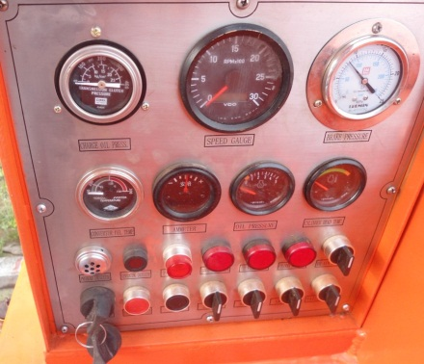 Control Board 控制面板
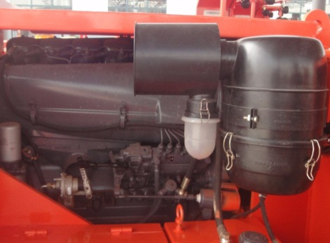
Central Articulated
动力机构
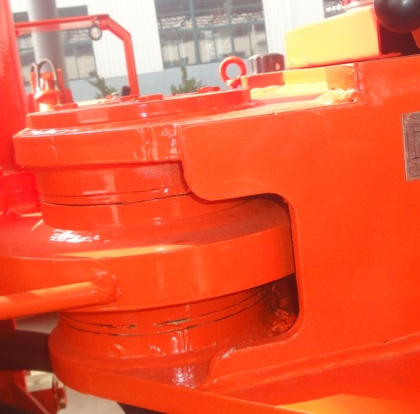
Central Articulated 中央铰接

Remote Control System遥控系统
- Communication Mode：WIFI-AdHoc / AP
- The service and control funcations are as same as manual mode, it’s reliable and easy to operate.
与驾驶室操作相比具有相同的控制装置，便于操作，性能可靠
- Remote and Manual mode can be shifted freely.
遥控/手动任意切换，互不影响
- Each indicators show operation status of each system.
工作指示：指示灯指示系统工作状态
- The accelerator, Boom up&down, Bucket loading&unloading, Turn left&right are proportional.
比例控制：油门控制、大臂升臂/降臂、铲斗装料/卸料、左转/右转；
- Control Switches: Start&Stop, Emergency, Forward&Reverse, Gear shift, Parking brake, Service brake, head&tail lights, horn, etc.
开关控制：启动、熄火、前进/后退、快/慢档、停车制动（驻车刹车）、行车制动（辅助刹车）、前灯、后灯、喇叭；
- Safe Mode: The emergency brake system will be enabled while Communication failure, vehicle failure, operation failure. 安全模式：通信故障、机车故障、操作错误时启动紧急刹车保护；
- The battery is recharged. 采用可充电电池

Configuration: 主要配置
Remote control unit, Signal reveiver unite, Hydraulic System, Electric unit.
主要配置包括：操作单元、车载单元、液压单元、电气单元

Remote control Unit操作单元
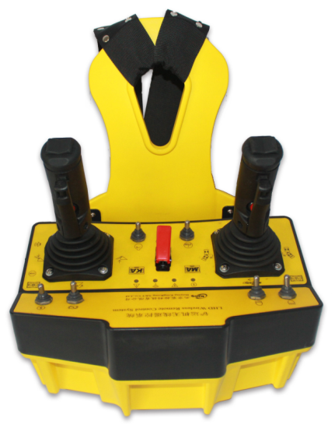
- Voltage: 12.8V DC
- Current: < 95mA
- Wireless communication distance: ＞80m
- Wireless signal frequency: 2.4GHz，IEEE 802.11b/g/n；
- Signals transmission rate: 1Mbps；
- Battery Type: 12.8V DC/1.4Ah Lithium battery
- 20 routes Digital input interface, 8 routes Analogue input interface

Hydraulic System车载单元
- Voltage: 24VDC；
- Current: ＜500mA (No load, it depends on load)
- Wireless communication distance: ＞80m
- Wireless signal frequency: 2.4GHz，IEEE 802.11b/g/n；
- Signals transmission rate: 1Mbps；
- 20 routes on-off control signal output, 8 routes PWM proportional control signal output.
- It can extend digital outputs, analogue or digital inputs.
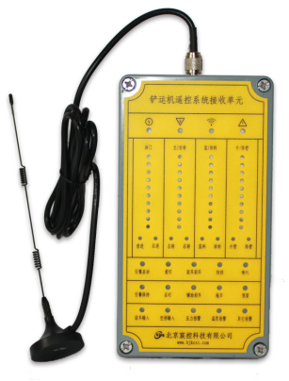

1.5立方铲运机参数对比
 | XYWJY-1.5 | LH203
额定载重量 kg | 3500 | 3500
斗容 m³ | 1.5 | 1.5
操作质量KG | 11200 | 8700
翻斗铲取力KN | 55 | 55
发动机 | BF4M1013EC | BF6L914
功率 | 115KW/2300RPM | 71.5KW/2300RPM
变矩器 | DANA C272 | DANA SOHC2122
变速箱 | RT20326 | RT20324
车桥 | XINGYE | DANA 14D1441
轮胎 | 12.00-24 | 12.00-20 20PLY
长度 mm | 6750 | 7040
宽度 mm | 1760 | 1480
高度 mm | 2080 | 1840
最大卸载高度 mm | 1476 | 1220
卸载角度 | 45 | 45
最小卸载距离 mm | 1076 | 1155
最小离地间隙 mm | 286 | 260
轴距 mm | 2501 | 2505
转弯半径 内/外 mm | 2660/4720 | 2740/4685
转向角度 | 40 | 40
车桥摆动角度 | 8 | 10
举升缸径 mm | 125*2 | 180*1
举升压力Mpa | 14 | 21
翻斗缸径 mm | 150 | 140
翻斗压力Mpa | 14 | 21
转向缸径 mm | 90 | 100
转向压力Mpa | 14 | 15
举臂时间 s | 6 | 5.5
落臂时间 s | 4 | 2.9
翻斗时间 s | 3 | 3
最大牵引力KN | 90 | \
车速 km/h
1档 | 4.4 | 5
2档 | 10.7 | 9.3
3档 | 19.4 | 24
4档
发电机 | 24V*35A | 24V*55A
启动马达 | 4KW | 4KW
蓄电池 | 100Ah*2 | 70Ah*2
照明灯 | 40w | 65w
遥控系统 | 北京ELINK | 德国HBC

