XYWJ-1.5 Underground Diesel LHD(铲运机)
XYWJ-1.5 Diesel LHD View:
I. Main Configuration
主要配置
1. |  | Diesel Engine:  发动机:
 |  | Manufacture:  制 造 厂 |  | DEUTZ  德国DEUTZ公司
 |  | Model:  型 号: |  | BF6L912W (Air-cooled)
 |  | Rated Power:  额 定功 率: |  | 63KW@2300RPM
 |  | Optional Engine:  可 选： |  | F5L914(70KW@2300RPM)
2. |  | Hydraulic Torque Converter:  液力变矩器:
 |  | Manufacture:  制 造 厂: |  | DANA  美国DANA公司
 |  | Model:  型 号: |  | C270 Series
3. |  | Power Shift Transmission:  动力换档变速箱:
 |  | Manufacture:  制 造 厂: |  | DANA  美国DANA公司
 |  | Model:  型 号: |  | RT20000 Series
 |  | Type:  类 型: |  | Power Shift  动力换档
 |  | Gears:  档位数: |  | 3
4. |  | Drive Axle:  驱动桥
 |  | Manufacture:  制 造 厂: |  | Yantai Xingye Machinery  烟台兴业机械股份有限公司
 |  | Model:  类 型: |  | Front axle features NO-SPIN differential, the rear axle has self-lubricating and oscillates a total 16° (8° each side).  防滑差速器，后桥带有自润滑摆动架，摆动角±8°。
5. |  | Braking System  制动系统
 |  | Components:  组 成: |  | SAHR brakes for service operation as well as parking/ emergency. SAHR工作制动 、停车制动、紧急制动
 |  | Features:  特 点: |  | These brakes are the Spring Applied, Hydraulically Released type, with fully enclosed, multiple wet discs that are force-cooled at each wheel end.  工作制动、停车制动为液压释放，弹簧释放，全封闭式湿式多片摩擦片集成在轮边上。
6. |  | Hydraulic System  液 压 系 统:
 |  | Components:  组 成: |  | Service system, steering system, braking system, charging system  工作系统、转向系统、 制动系统、 补油系统
 |  | Features:  特 点: |  | The servicing pump, steering valve, multi-directional control valve, conversion valve, are all imported famous brand. Such as the steering pump adopts BOSCH brand, purge hydraulic valve and foot valve adopts Parker SAFIM brand.  主要元件采用进口件（工作泵、多路阀、转向阀、转向泵、充液阀、脚踏阀等。）
 | 7. | Electrical System  电器系统：
 |  | Power Voltage:  工作电压： |  | 24V
 |  | Electrical Appliance:  电 器： |  | Siemens Brand and Zhengtai Brand  西门子和正泰产品
 | 8. | Others:  其 它：
 |  | Tires:  轮胎： |  | Guizhou brand, 12.00/2.5-24  贵州前进 12.00/25-24
 |  | Hydro-cylinder:  油 缸： |  | Self-made, the grease oil adopts imported combined seal  自制，油封为进口材料组合式密封
 |  | Blade:  铲 刃： |  | Hardness: HB500, adopt special alloys and anti-wear material. 硬度大于500HB, 采用特种合金耐磨钢
 | II. |  | Main Technical Date:  主要技术参数：
 | 1. |  | Main Dimensions:
 |  |  | Dimension (transport):  外形尺寸（运输状态）： |  | 6750mm×1760mm×2080mm
 | 2. |  | Weights &Axle Loading Weight:  重量和桥载荷：
 |  |  | Bucket Capacity (SAE Heaped):  铲斗容积（SAE堆装） |  | 1.5 m³ (2 yard³)
 |  |  | Rated Loading Capacity:  额定载重量： |  | 3000 KG
 |  |  | Machine Weight:  整机重量： |  | 11200 KG
 | 3. |  | Driving Speeds Forward and Reverse ：  运行能力：
 |  |  | 1st Gear:  1档： |  | 0~4.4 Km/h
 |  |  | 2 nd Gear:  2档： |  | 0~10.7 Km/h
 |  |  | 3 rd Gear:  3档 |  | 0~19.4 Km/h
 | 5. |  | Distance:  距离：
 |  |  | Max. Discharging Height  最大卸载高度： |  | 1476mm
 |  |  | Min. Discharging Distance:  最小卸载距离： |  | 1076mm
 | 6. |  | Capacities:  能 力：
 |  |  | Max. Climbing Ability:  最大爬坡能力： |  | 15°
 |  |  | Max. Tractive Force:  最大牵引力: |  | 98 KN
 |  |  | Max. Shovel Force:  最大铲取力： |  | 92KN
 | 7. |  | Steering:  转 向：
 |  |  | Max. Steering Angle:  最大转向角： |  | ± 40 °
 |  |  | Min. Steering Radius:  最小转弯半径： |  | Inner:2660mm  内侧：2660mm | Outer: 4720mm  外侧：4720mm
 | III. |  | Scooptram Parts Picture:  整机部分图片：
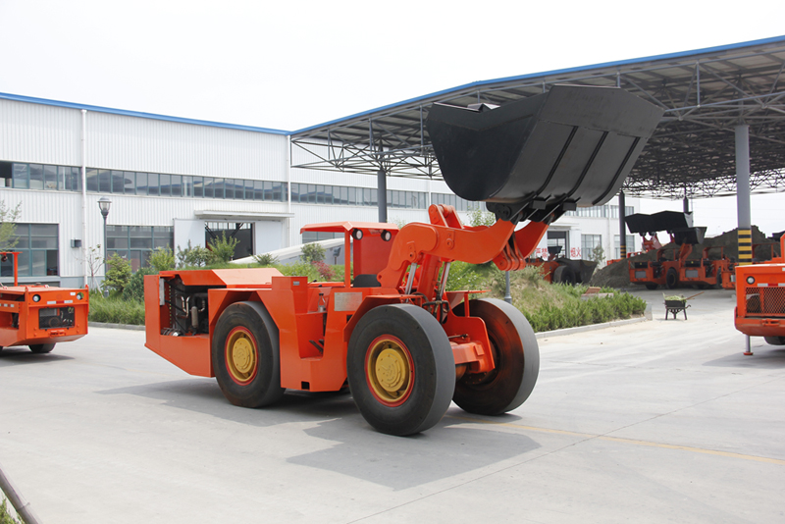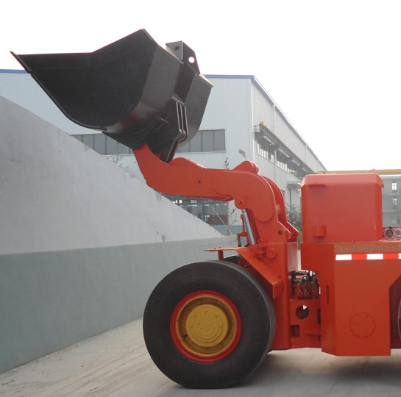
Complete Machine Working Part
整机图 工作机构
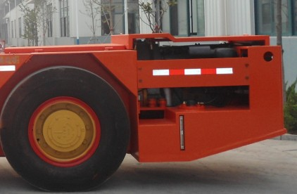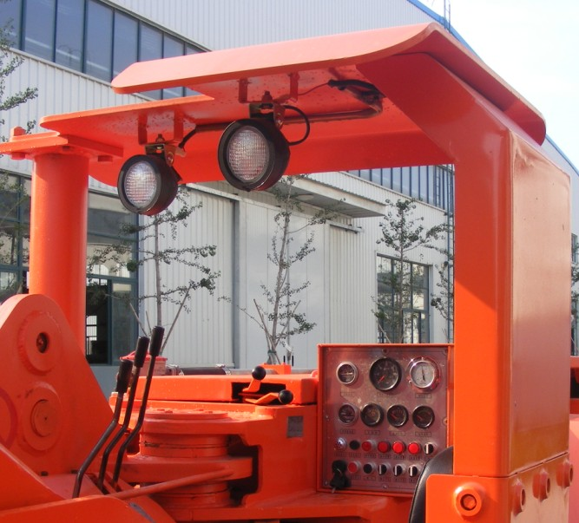
Rear Car Driver’s Cab
后车体 驾驶
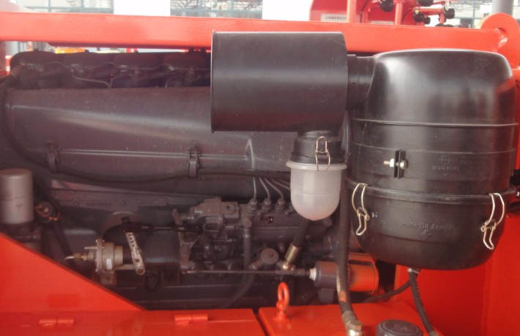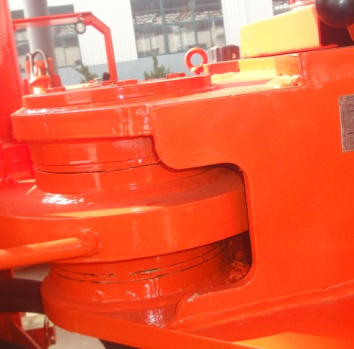
Driving Part Central Articulated
动力机构 中央铰接
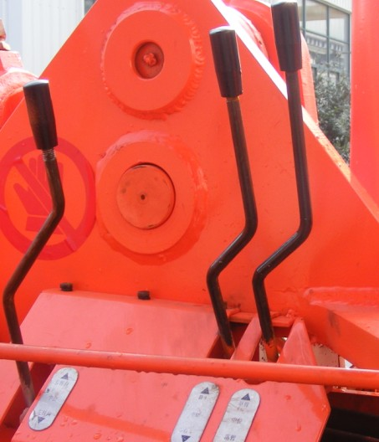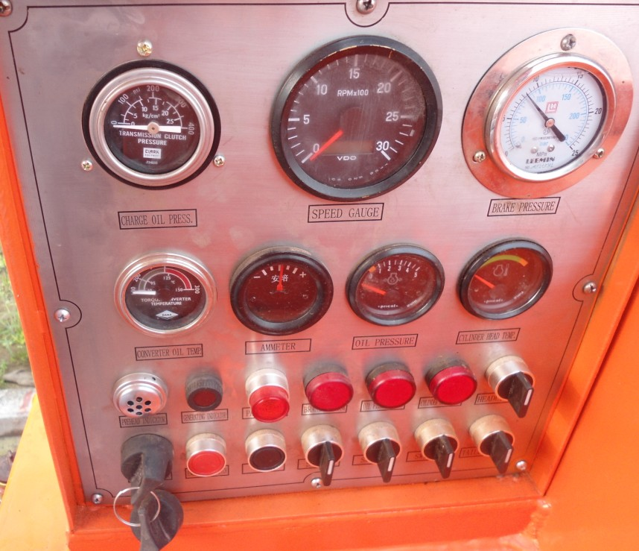
Operation Part Control Board
操纵机构 控制面板

