YWJD-1 Underground Electric LHD Technical Date
XYWJD-1电动地下铲运机技术简介
XYWJD-1 Electric LHD Drawing:

I. Main Configuration
主要配置
1. | Motor:  电动机:
 | Model:  型 号: | HM2-225M
 | Power Supply:  电源电压： | 3 Phase 380 V 50HZ
2. | Hydraulic Pump:  液压泵:
 | Manufacture:  制 造 厂: | Adopt Famous Brand  进口国外名牌
 | Model:  型 号: | PV22
3. | Hydraulic Motor :  液压马达:
 | Manufacture:  制 造 厂: | Adopt Famous Brand  进口国外名牌
 | Model:  型 号: | MV23
4. | Power Shift Transmission:  变速箱：
 | Manufacture:  制 造 厂: | Yantai Xingye Machinery Co, Ltd.  烟台兴业机械股份有限公司
 | Model:  型 号: | 2 0800
5. | Drive Axle:  驱动桥
 | Manufacture:  制 造 厂: | Yantai Xingye Machinery Co, Ltd.  烟台兴业机械股份有限公司
 | Type:  特点: | PC15
6. | Tires:  轮胎：
 | Manufacture:  制 造 厂: | Xinfei Yalun Co. Ltd.  新飞亚轮胎
 | Model:  型号: | 10.00-20
7. | Treble Pump:  三联泵：
 | Manufacture:  制 造 厂: | Sichuan Changjiang Hydraulic Components Co. Ltd  四川长江液压
 | Model:  型号: | CBQT
8. | Multiway Directional Valve:  多路换向阀：
 | Manufacture:  制 造 厂: | Sichuan Changjiang Hydraulic Components Co. Ltd  四川长江液压
 | Model:  型号: | ZL
9. | Working Group(Frame,Big Arm, Bucket)：  工作机构（机架、大臂、铲斗等）
 | Manufacture:  制 造 厂: | Yantai Xingye Machinery Co, Ltd.  烟台兴业机械股份有限公司
 | Model:  型号: | 2 0100
10. | Hydraulic Oil Cylinder(Tipping Bucket, Lifting, Steering)  液压缸（翻斗、举升、转向）
 | Manufacture:  制 造 厂: | Yantai Xingye Machinery Co, Ltd.  烟台兴业机械股份有限公司
 | Model:  型号: | 2 0300 01/2 0300 07/2 0500 02
11. | Cable  电缆：
 | Manufacture:  制 造 厂: | Jiangsu Cable
 | Model:  型号: | 3*16 +1*10
12. | Braking System  制动系统
 | Components:  组 成: | Service System and Parking System  工作制动 、停车制动
 | Features:  特 点: | Service/ Parking brakes are spring applied, hydraulically released (SAHR)  工作制动、停车制动为液压制动，弹簧释放  Fully enclosed, force cooled, multi-discs wet at each wheel end  全封闭液压湿式多盘制动器
13. | Hydraulic System  液 压 系 统:
 | Components:  组 成: | Service system, steering system, braking system,  Cable system  工作系统、转向系统、 制动系统、 卷揽系统
 | Features:  特 点: | The servicing pump, steering valve, multi-directional control valve, conversion valve, are all imported famous brand. Such as the steering pump adopts BOSCH brand, purge hydraulic valve and foot valve adopts SAFIM brand.  主要元件采用进口件（工作泵、多路阀、转向阀、转向泵、充液阀、脚踏阀等。）

II. | Main Technical Date:  主要技术参数：
1. | Main Dimensions:
 | Dimensions (Transport):  外形尺寸（运输状态） | 6090mm×1300mm×2000mm
2. | Bucket Capacity (SEA Stowage):  铲斗容积（SEA堆装） | 1 m³
 | Rated Loading Capacity:  额定载重量： | 2000 KG
 | Machine Weight:  整机重量： | 72000 KG
3. | Running Speed:  运行速度： | 0-8 KM/H
5. | Distance:  距离：
 | Max. Discharging Height  最大卸载高度： | 1050mm
 | Min. Discharging Distance:  卸载距离： | 860mm
 | Wheel Base:  轴 距： | 2200mm
 | Leaving Angle:  离 去 角： | 15°
 | Min. Off-ground Clearance:  最小离地距离： | 200mm
 | Rear Axle Swing Axle:  后桥摆动角： | ±8°
6. | Capacities:  能 力：
 | Max. Climbing Ability:  最大爬坡能力： | 15°
 | Max. Tractive Force:  最大牵引力: | 56 KN
 | Max. Shovel Force:  最大铲取力： | 48 KN
7. | Steering  转 向：
 | Max. Steering Angle:  最大转向角： | ± 38°
 | Min. Steering Radius:  最小转弯半径： | Inner: 2540mm  内侧: 2540mm | Outer: 4260mm  外侧：4260mm
8. | Cable Reel:  电 缆:
 | Type:  特点： | Random wrap with automatic tension control  随机用自动张力控制
 | Cable reel Length:  电缆长度： | 100 m  有效长度100m
III. | Scooptram Parts Picture:  整机部分图片：
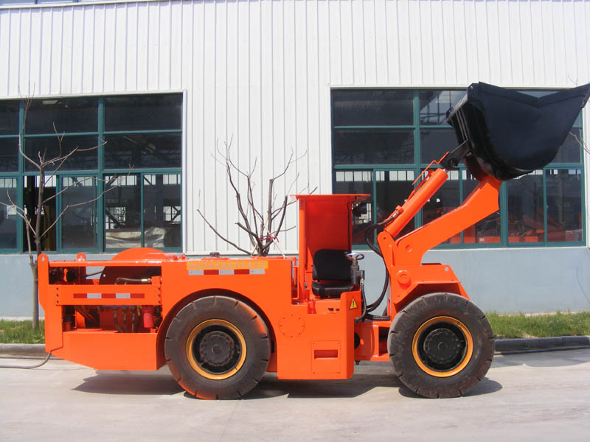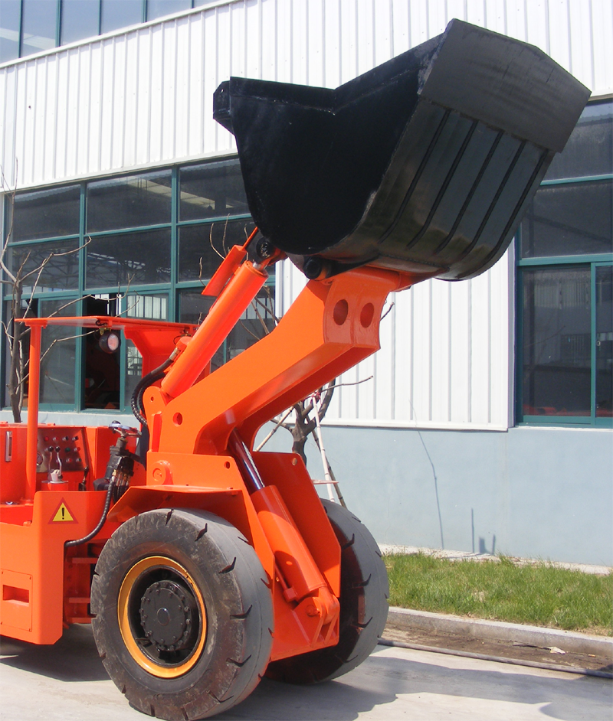
Complete Machine Front Frame & Working Part
整机图 前机架及工作机构
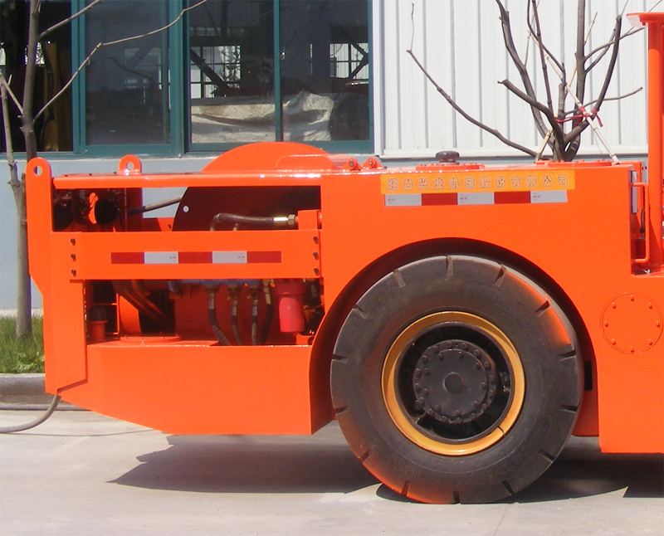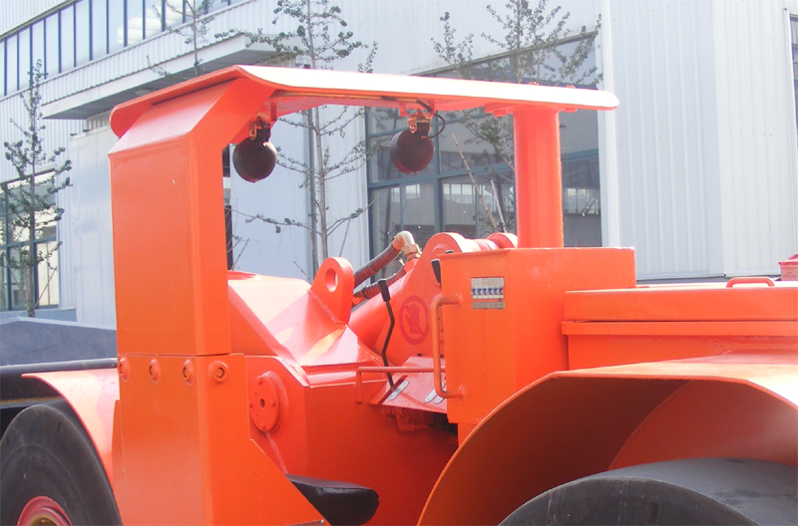
Rear Car Driver’s Cab
后车体 驾驶

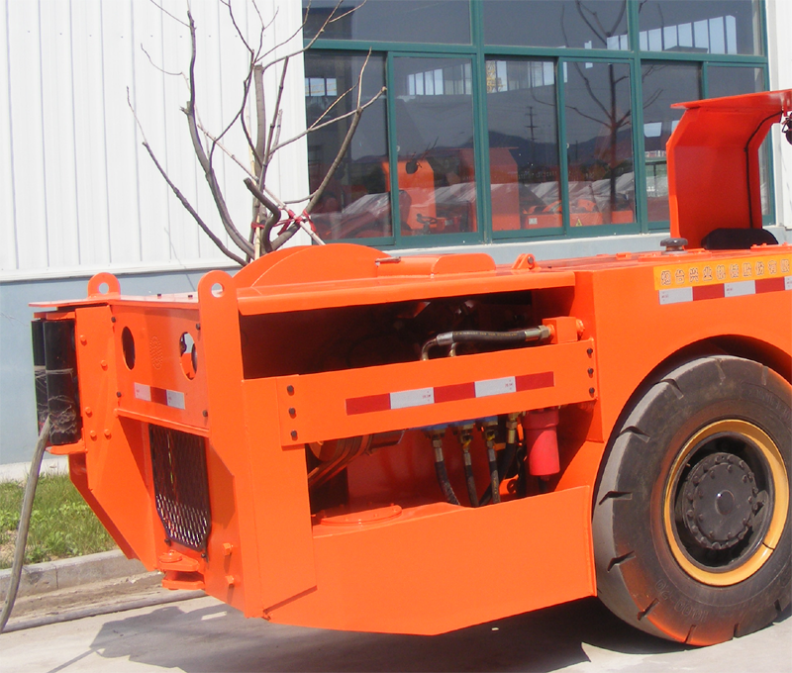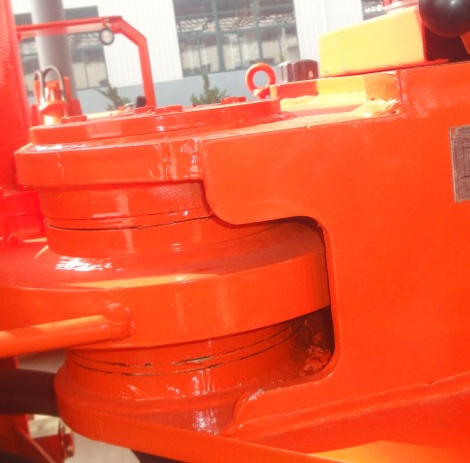
Driving Part Central Articulated
动力机构 中央铰接

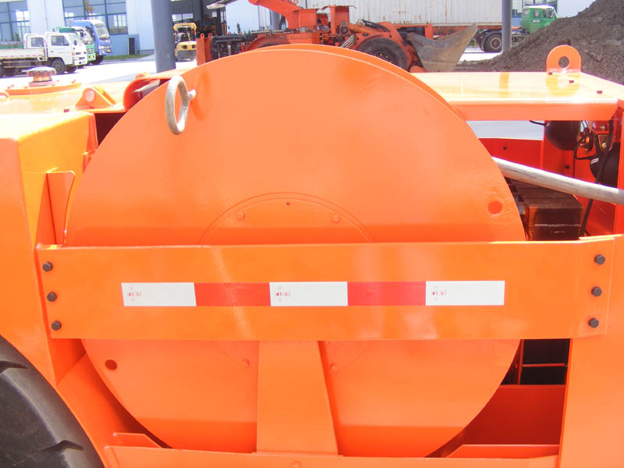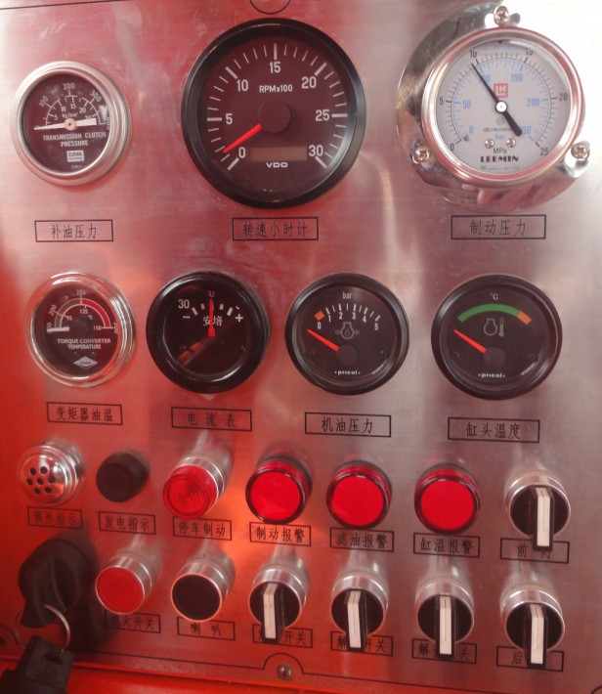
Cable Drum Control Board
电缆卷筒 控制面板
IV. | XYWJD-1 Underground Electric Loader Features:  XYWJD-1电动铲运机的技术先进性:
XYWJD-1 Underground Electric Loader is completely developed by our R&D staff, it is a new underground diesel loader, compare with the original loader, the features as below:
我公司研制生产的XYWJD-1型电动铲运机，完全是我公司自己研制的全新型铲运机，与原机型比较有以下优点：
1.. | A. The original loader adopts two rear wheels in the swing rack in order to solve the rough road, while the whole machine because of the road id too rough, shaking force and turbulence force are acting in the rear swing rack. As a result the swing rack is broken easily. Besides, during the loading it is easily to make the second gear or the third gear working harder, and also greatly reduce the shovel force. So the bucket loading is often overloaded and the oil temperature is quickly raised.  A.原机型为解决道路的高低不平，采用了摆动架摆动两个后轮，摆动角度仅为±6°，而且整个后车体由于巷道的不平，产生的摆动力和颠簸力都作用在后摆动架上，造成摆动架经常断裂。此外，由于巷道的高低不平，特别在铲装时，很容易造成二轮吃力或三轮吃力，大大降低了铲取力，反而造成铲装经常过载，系统油温很快升高。  B. The new XYWJD-1 loader adopts rear body swing, and the whole rear swing angle is ±8°(according to your needs to adjust).That ensure the four wheels can contact with the ground, greatly increase the shovel force and reduce the failure rate.  B.我公司生产的XYWJD-1电动铲运机采用后车体摆动，整个后车体摆动角度为  左右±8°（需要时可以调大）。这样保证四个车轮始终保持全部与地面接触，大大增强了有效铲取力，降低了故障率。
2. | Running System adopts full hydraulic control  行走系统采用了全液压控制：  A. The original loader’s running system adopts mechanically control, two foot control board and through operation to connect the pole in order to control the pump forward and back. Because of the pull pole adopts a few parts to articulate, the results as flows: A. It is difficult to adjust the front and rear direction. B. Because of the articulated is easily worn, and accumulated error, finally the pump swash plate can not reach the max. Angle.  A.原机型行走系统采用机械控制，两个脚踏板，通过操作连杆，控制泵前进、  后退，以此进行行走部分操作。由于拉杆采用几部分铰接而成，所以容易造成1、前后位调节困难 2、由于铰接磨损，造成累积误差，最终使泵斜盘达不到最大位置，发挥不出效率。  B. The new XYWJD-1 loader adopts full hydraulic control, the foot valve control hydraulic valve to make the forward and back operations. No matter what the circumstances, the pump swash plate can reach the Max. Angle,  achieve the max. Shovel force and easily operation.  B. 我公司生产的XYWJD-1电动铲运机采用全液压控制，由脚踏阀控制液控阀，  实行前进、后退作业，无论在什么情况下，泵斜盘都能达到最大斜角，实现最大铲取力，使铲运机的铲取力增大，控制灵敏。
3. | Comparison of working system:  工作系统的比较:  A.The original loader adopts manual operation poles, to pull the spool of multi-direction control valve make the actions of fall, lift, tipping, return. Due to the underground mine bad situation, multi-direction control valve be precise .If the fall thing on the valve spool ,it will cause strain .And the valve be broken frequently.  原来机型采用手动操作拉杆，拉动多路换向阀上的阀芯，实现落、举、翻、收斗的动作，由于井下环境恶劣，多路阀阀芯要求精密，常由于落渣在阀芯上，造成拉伤，使多路阀损坏比较频繁。  B. The new XYWJD-1 loader adopts pilot hydraulic control, only the hydraulic pipe is outside. So it makes the operation more easier, simple and high efficiency. The whole working system adopts Vickers technological produced triple pump instead of original single pump and double pump system.  我公司生产的XYWJD-1电动铲运机采用先导－液控系统，露在外面的是只有液压管路，使操作更灵敏，简单，工作系统更加有效。整个工作系统采用威格士技术生产的三联泵，取代了原来的单泵加双泵系统。
4. | Comparison of cable system:  卷揽系统比较：  The original loader adopts three pieces of overflow valve to limit the pressure, and great random of pressure regulating,which always break down. While the new XYWJD-1 Loader adopts hydraulic control cable valve, forward and reverse of foot valve separately filling the oil, so the cable system is very safe and reliable, also low failure rate.  原来机型采用三个溢流阀限压，液动阀换向，调压的随意性很大，常常出现故障。我公司生产的XYWJD-1电动铲运机，采用液控卷缆阀，由脚踏阀的前进、后退油口分别供油，使卷缆系统既安全可靠，又故障率低。
5. | New Parking Brake:  采用了全新的停车制动  The new XYWJD-1 loader is parking brake, and adopts transmission case drive the disc brake. Spring brake, hydraulically released brake .And the brake is full closed, the underground mine situation has no effect on it, so safety and reliability. The working brake adopts accumulator emergency brake ,high efficiency. Even on 20° slope can be full loaded, good reliability.  我公司生产的XYWJD-1内燃铲运机停车制动，采用传动齿轮箱带动摩擦片制  动器，弹簧制动，液压力解除制动。而制动器为全封闭式，不受井下环境影响，安全可靠。这是原来机型所没有的。工作制动采用储能器紧急制动，增加制动的有效性。在20°的斜坡上满载制动，安全可靠，是很多矿上打斜坡道的必选设备。
5. | The bucket adopts V type structure, and the front blade adopts special anti-wear steal ,reduces the resistance of picking shovel and increase the working life.  铲斗设计，采用了V型结构，前铲刃采用特种耐磨钢板，减少了铲取阻  力，提高了铲斗寿命。
6. | The new XYWJD-1 loader adopts 16Mn alloy steal. After finished process then through 24 hours tempering, relieving of internal stress to ensure the machine non-deforming. After tempering ,it adopts blast sanding and don’t drop paint.  除上述先进性外，在车架大臂加工中，我公司生产的XYWJD-1内燃铲运机全部采用16Mn锰钢板，加工完后进行24小时回火处理，消除内应力，确保机架不变型。回火后采用喷砂处理，不掉漆。
V. | Main Spare Parts Technical Flow:  主要零部件加工工艺
1. | The plug welding working process of the front and rear rack, large arm, bucket etc as below:  前后机架、大臂、铲斗等铆焊件的制作加工:
1.1 | The front and rear rack is the key part in the whole machine, so the quality is directly related to the whole machine. The deformation of the rack will directly cause the other parts of damage, even cause the whole machine scrap. Considering the machine quality and working life, so the whole machine adopts 460C aluminium alloy  The technical flow:  Baiting- Bending Plaits- Connection and Alignment-Welding-Tempering (The tempering temperature is550~650℃,elimination of the jointing stress and deformation )- Sand Blasting- Bore a hole-Polishing and assemble with primer spray  前后机架为整机的关键部件，质量的好坏直接关系到整机的质量，机架的变形会直接造成其他零部件的损坏，甚至造成整机的报废，所以整个机架全部采用460C合金钢板,我们的工艺为：  下料-折弯整形-对接找正-焊接（采用氩气、二氧化碳气体保护焊）-回火（回火温度550～650℃，消除焊接应力变形）-喷砂处理-镗孔-打磨喷底漆-装配。
1.2 | The car adopts 460C aluminum alloy steel, the technical flow as above.  大臂、铲斗采用460C合金钢板（铲刃、铲牙采用了特种耐磨钢），其制作工艺与前后机架同。
2. | The Oil Cylinder Main Spare Parts Technical Flow:  油缸主要件加工工艺
2.1 | The cylinder Barrel: welding oil mouth-honing, to ensure out-of-roundness of the cylinder  Barrel  缸筒：焊接油口-珩磨，保证缸筒不圆度；缸头加铜套
2.2 | Piston Rod: Forging-Rough Turning-Hardening and Tempering-Finish Turning-Bore a hole-Grinding-Hard Chrome Plating-Polished Finish  活塞杆：锻打-粗车-调质-精车-镗孔-磨削-镀硬铬-抛光处理
2.3 | Pressure Test: The assemble oil cylinder through testing pressure and testing leak of test-bed, after confirming everything is well then to be used. The testing pressure is 20Mpa  试压：装配完的油缸经试验台的试压、试漏，确认无误后方可用于整机装配。试压压力为20Mpa。
2.4 | The oil cylinder seal adopts the combination seal.  油缸密封采用进口材料特制。
3. | The Main Shaft Parts Technical Flow:  各主要轴类件加工工艺
Baiting-Rough Turning-Tempering-Finish Turing-Quenching-Grinding
大臂前轴、大臂后轴、中间铰接轴、举升、翻斗销轴等：材质：40Cr
The Material of front axle of big arm, rear axle of big arm, articulated in middle axle,lift, tipping bucket and pin roll etc: 40Cr
下料-粗车-调质-精车-淬火-磨削
4. | All shaft sleeves are adopted high force brake, don't need to add the lubricating oil, longer working life.  所有轴套采用高力黄铜＋石墨，不必加润滑油，使用寿命更长。
VI. | Machine Picture:  铲运机图片：

