XYUK-10 Underground Truck Technical Date
XYUK-10地下运矿车技术简介
XYUK-10 Underground Truck Drawing:
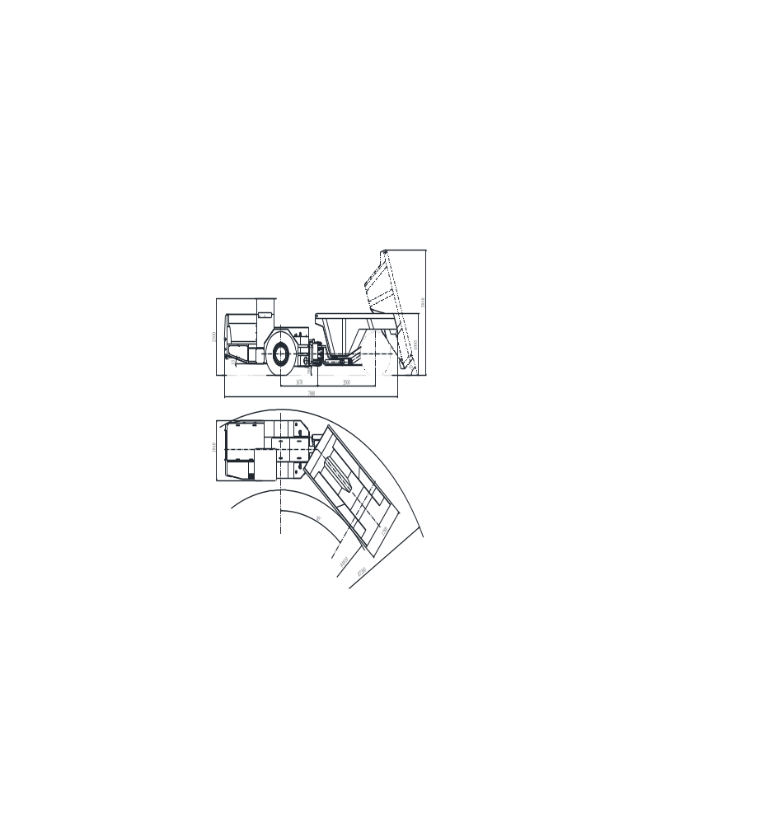

I. Main Configuration
主要配置：
1. | Diesel Engine:  内燃发动机：
 | Manufacture:  制造厂： | German DEUTZ Company  德国道依茨公司
 | Model:  型号： | BF4M1013EC/ QSB4.5
 | Rated Power:  额定功率： | 115KW/ 2300RPM
2. | Hydraulic Torque Converter:  液力变矩器：
 | Manufacture:  制造厂： | America DANA Company  美国德纳公司
 | Model:  型号： | C270
 | Type:  特点： | Single Grade of Two-Element, with hydraulic drive pump  单级二元件，带液压泵驱动装置
3. | Power Shift Transmission:  变速箱：
 | Manufacture:  制造厂： | America DANA Company  美国德纳公司
 | Model:  型号： | R32000
 | Type:  类型： | Power Shift  动力换挡
 | Gears:  档位： | 4
4. | Drive Axle  驱动桥：
 | Manufacture:  制造厂： | Yantai Xingye Machinery Co.,Ltd  烟台兴业机械
 | Type:  类型： | Rigid driving axle planet of NO-SPIN Antiskid differential, with wet and multi-disks brake  NO-SPIN防滑差速器的刚性行星驱动桥，带轮边湿式多盘制动器。
5. | Braking System  制动系统
 | Components:  组成： | Working brake and parking brake  工作制动、停车制动
 | Features:  特点： | Adopts Posi-Stop Spring Brake, full hydraulic multi-disks wet brake in each wheel  Its features,as below: fully enclosed hydraulic cooling, good braking ability, set to the working ,parking and emergency brake as a whole, simplified the brake system.  采用Posi-Stop弹簧制动器，全液压多盘湿式制动器作用在每个车轮上，其特点是全封闭液冷，制动能力强，集工作、停车、紧急制动与一体，简化了制动系统。
6. | Hydraulic System  液压系统
 | Components:  组成： | Working system, steering system, braking system, fill oil system, cable system  The work steering pump, multi-directional control valve, conversion valve are all adopted PARKER brand.  工作系统 转向系统 制动系统 补油系统 卷缆系统  工作转向泵、多路换向阀、转向阀选用PARKER产品
7. | Others:  其他：
 | Tire:  轮胎： | 14.00-24
 | Hydro-cylinder:  油缸： | Self-made, the grease oil adopts imported combined seal  自制，油封为进口组合式密封
II. | Main Technical Parameter:  主要技术参数：
1. | Weight:  重量：
 | Dimension (transport):  外形尺寸（运输状态） |  | 7800 mm×1840 mm×2350 mm
 | Bucket Capacity (SEA Stowage):  铲斗容量： |  | 5 m³
 | Loading Height  装载高度： |  | 1895mm
 | Discharging Angle:  卸载角度： |  | 70°
2. | Machine Weight  重量：
 | Weight:  整机重量： |  | 12100 KG
 | Rated Loading Weight:  额定载重量： |  | 10000 KG
3. | Operation Capacity  运行能力
Driving Speed:
行驶速度：
 | First Gear::  1档： |  | 0~3.5Km/h
 | Second Gear:  2档： |  | 0~7 Km/h
 | Third Gear:  3档： |  | 0~13 Km/h
 | Forth Gear:  4档： |  | 0~23 Km/h
 | Max. Climbing Ability:  最大爬行能力： |  | 15°
 | Max. Attraction Force:  最大牵引力： |  | 128KN
4. | Steering  转向：
 | Max. Steering Angle:  最大转向角： |  | ± 40 °
 | Min. Steering Radius:  最小转向半径： |  | Inter: 4810 mm  内侧:4810 mm | Outer:7260 mm  外侧:7260 mm

III. | XYUK-10Underground Dump Truck Features:  XYUK-10地下运矿卡车具有如下先进性:
1. | Adopts America DANA brand torque converter with hydraulic pump and power shift transmission. The working pump、valves are adopted PARK-COMMERCIAL brand, which is the most top hydraulic products in the world.  采用了美国德纳（DANA）带液压泵驱动装置变矩器和动力换挡变速器。住工作泵、阀采用PARK-COMMERCIAL产品，均为世界顶级液压产品。
2. | The drive axle adopts special driving axle with wet and multi-disks brake. The working brake adopts hydraulically brake, released spring. Also the drive axle’ quality is the best product in China. All the bearings are adopted TIMKEN brand, the disc brake is imported the good brand, and the front drive axle adopts America NO-SPIN antiskid differential.  桥采用铲运机专用驱动桥，轮边多盘湿式制动，工作制动采用液压制动，弹簧解除制动。桥的整体质量居国内最好产品，轴承全部选用TIMKEN轴承，制动器摩擦片采用进口，前桥采用了美国进口NO-SPIN防滑差速器；
3. | Adopts dual lift and dual steering oil cylinder to make the whole equipment more stable and more powerful during steering. The lifts, steering oil cylinders, oil cylinder seal elements are all adopted the foreign famous brand, therefore improve the working lift of oil cylinder.  采用双举升、双转向油缸，使整机更加平稳，转向更加有力。举升、转向油缸，油缸密封件全部采用进口材料，提高了油缸的使用寿命；
4. | The swing adopts slewing bearing type swing, to reduce the failure rate.  摆动采用回转轴承式摆动，减少了故障率；
5. | All the bolts of the vehicle are adopted high strength 8.8 or above, all the copper bushes are adopted the most advanced lubrication collar.  整车所有螺栓均采用高强度8.8级以上螺栓，所有铜套均采用当今最先进的免润滑轴套.
IV. | Main Spare Parts Technical Flow:  主要零部件加工工艺:
1. | The plug welding working process of the front and rear rack, large arm, bucket etc as below:  前后机架、大臂、铲斗等铆焊件的制作加工:
1.1 | The front and rear rack is the key part in the whole machine, .so the quality is directly related to the whole machine. The deformation of the rack will directly cause the other parts of damage, even cause the whole machine scrap. Considering the machine quality and working life, so the whole machine adopts the 460C alloy steel.  The technical flow:  Baiting- Bending Plaits- Connection and Alignment-Welding-Tempering (The tempering temperature is550~650℃,elimination of the jointing stress and deformation )- Sand Blasting- Bore a hole-Polishing and assemble with primer spray  前后机架为整机的关键部件，质量的好坏直接关系到整机的质量，机架的变形会直接造成其他零部件的损坏，甚至造成整机的报废，所以整个机架全部采用460C合金钢,我们的工艺为：  下料-折弯整形-对接找正-焊接-回火（回火温度550~650℃，消除焊接应力变形）-喷砂处理-镗孔-打磨装配喷底漆
1.2 | The car adopts 460C alloy steel, the technical flow as above.  车厢采用460C合金钢，其制作工艺与前后机架同.
2. | The Oil Cylinder Main Spare Parts Technical Flow:  油缸主要件加工工艺:
2.1 | The cylinder Barrel: welding oil mouth-honing, to ensure out-of-roundness of the cylinder  Barrel  缸筒：焊接油口-珩磨，保证缸筒不圆度。
2.2 | Piston Rod: Forging-Rough Turning-Hardening and Tempering-Finish Turning-Bore a hole-Grinding-Hard Chrome Plating-Polished Finish  活塞杆：锻打-粗车-调质-精车-镗孔-磨削-镀硬铬-抛光处理
2.3 | Pressure Test: The assemble oil cylinder through testing pressure and testing leak of test-bed, after confirming everything is well then to be used. The testing pressure is 20Mpa  试压：装配完的油缸经试验台的试压、试漏，确认无误后方可用于整机装配。试压压力为20Mpa。
2.4 | The oil cylinder seal adopts the combination seal.  油缸密封采用组合密封
3. | The Main Shaft Parts Technical Flow:  各主要轴类件加工工艺
Baiting-Rough Turning-Tempering-Finish Turing-Quenching-Grinding
下料-粗车-调质-精车-淬火-磨削
The Material of front axle of big arm, rear axle of big arm, articulated in middle axle,lift, tipping bucket and pin roll etc: 40Cr
大臂前轴、大臂后轴、中间铰接轴、举升、翻斗销轴等的材质：40Cr
4. | All shaft sleeves are adopted lubricated oil copper bush.  所有轴套采用无油润滑铜套。
V. | Underground Mining Truck Pic.  地下运矿车图片：



