Underground Mining Truck XYUK-30
Technical specification
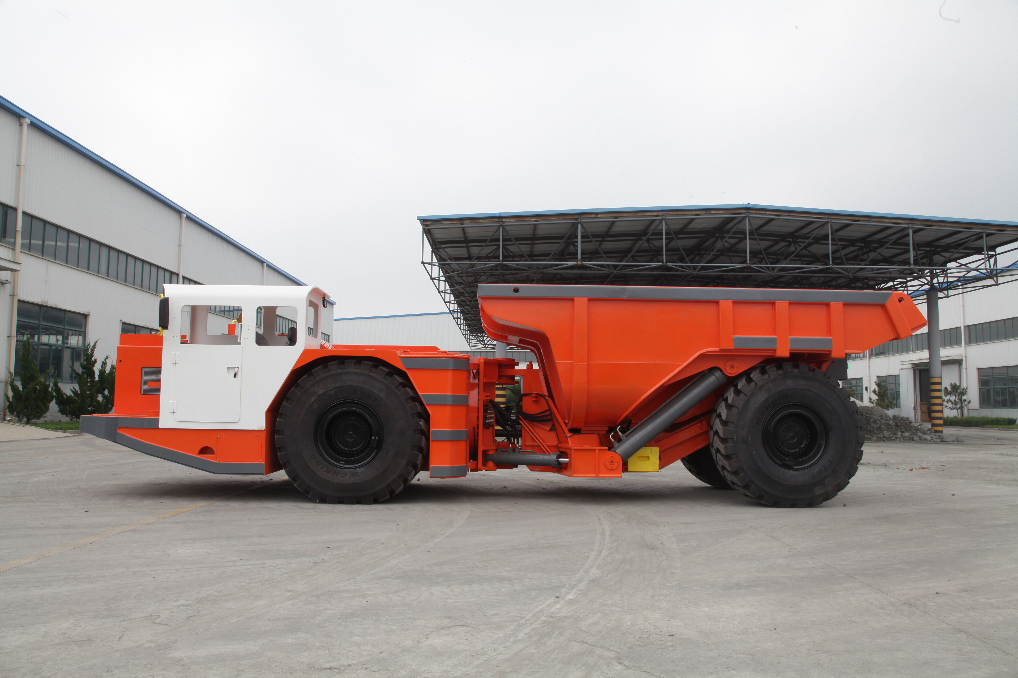
XYUK-30吨卡车是具有30公吨运载能力的地下矿用卡车，配置中央铰接摆动装置。XYUK-30的全新设计不仅提高了生产效率，还提高了井下运输、采矿与建筑作业的安全性、可维护性和操作舒适度。
Characteristics

Structure
1. Engine brake
2. Lockup for steering
3. 中央铰接摆动
4. 采用Ⅲ阶段发动机，减少尾气排放
Safe Operation
1.SAHR brake system
2.ROPS/FOPS Certificate

Comfortable Operation
1. Ergonomics Canopy with generous operation room
2. Adjustable operator’s seat
3.
4. Exhaust Emission per Tier Ⅲ
Efficient Production
- Matched Powertrain
- Digital Monitor & diagnose
- Lube Layout to maintain
Main Technical Parameter
主要技术参数

Bucket motion times
工作时间
Raising Time:  举斗时间: | 14s
Lowering Time:  落斗时间: | 10s
Max. Lifting Height:  最大举升时的整机高度: | 5715mm
Discharging Angle:  最大卸载角度: | 65°
Wheel Base:  轴距: | 5245mm
Leaving Angle:  离去角: | 15°
Rear Axle Oscillation Angle:  中央铰接摆动角: | ±8°
Min. Off-ground Clearance:  最小离地间隙: | 357mm
Max. gradeability:  爬坡能力: | 25%
Max. Steering Angle:  最大转向角: | ± 42 °
Dimension (tramming):  外形尺寸（运输状态） | 10130mm×2800mm×2580mm
Bucket Capacity(SAE):  铲斗容量(SAE) | 15m³
Weights
重量
Operating Weight:  操作重量: | 30000 kg
Rated Loading Capacity:  额定载重量: | 30000 kg
Axle weights without load
空载
Front Axle:  前桥载荷: | 19700kg
Rear Axle:  后桥载荷: | 10300kg
Axle weights with load
满载
Front Axle:  前桥载荷: | 28780kg
Rear Axle:  后桥载荷: | 31220kg
Driving Speeds Forward and Reverse
运行能力
First Gear:  1档: | 0~5.1km/h
Second Gear:  2档: | 0~9.2km/h
Third Gear:  3档: | 0~15.2km/h
Forth Gear:  4档: | 0~27.2km/h
Min. Steering Radius
最小转向半径
Outer / Inner:  外侧 / 内侧: | 8846mm/5107mm

Main Configuration
主要配置

Diesel Engine
发动机
Manufacturer:  制造厂: | Mercedes Benz  梅赛德斯奔驰
Model:  型号: | OM460 LA
Rated Power:  额定功率: | 315KW@1800 rpm
Features:  特点: | Water Cooled, Turbo Charged  水冷, 增压
Hydraulic Torque Converter
液力变矩器
Manufacture:  制造厂: | DANA  美国德纳
Model:  型号: | CL8000 Series
Power Shift Transmission
变速箱
Manufacture:  制造厂: | DANA  美国德纳
Model:  型号: | R6000 Series
Features:  特 点: | 前/后四档 电子控制  F4/R4 Electronic control
Drive Axle
驱动桥
Manufacture:  制造厂: | KESSLER  德国凯斯勒
Model:  型号: | D91
Tyres
轮胎
Manufacture:  制造厂: | China Tyres Company  泰凯英
Model:  型号: | Radi 26.5R25
Hydraulic System
液压系统
Components:  组成: | Servicing system, steering system, braking system, fill oil system  工作系统、转向系统、 制动系统 、补油系统
Features:  特 点: | Service and steering hydraulic systems are equipped with PARKER Hydraulic Pumps and Valves, and brake hydraulic system equipped with Mico hydraulic components.  The oil flow from steering hydraulic pump is directed to bucket hydraulics when steering is not used.  Rated Pressure of service hydraulics: 19Mpa  液压泵和阀采用派克品牌，制动系统液压元件采用米肯品牌。  采用双泵合流，减少能量损失。工作系统压力19Mpa
Braking System
制动系统
Components:  组 成: | Service/Parking/Emergency brake  工作制动、停车制动和紧急制动
Features:  特 点: | These brakes are spring applied, hydraulically released type (SAHR)，with fully enclosed, multiple wet discs that are forced-cooled at each wheel end.  工作制动、停车制动为弹簧制动，液压释放.  制动器为全封闭液压湿式多盘制动器

Electric System
电器系统
Alternator:  发电机: | 28V 80A
Batteries:  蓄电池: | 12VX2 165Ah
Lights:  工作灯: | Front: 7 pcs  Rear: 3 pcs
Sensors:  传感器: | Fuel/Oil level sensors, Sensors of service, steering, brake system, Limit Sensor  柴油、液压油油位传感器，工作、转向、制动、补油系统压力传感器，限位传感器
Alarm:  报警提示: | Red/green indicators  红绿指示灯  Rotation Warning Lamp  旋转报警灯  Low oil level warning/Oil pressure warning  低油位报警/油压报警
Monitor Screen:  显示器: | IFM CR1083
Controller:  控制器: | IFM CR2532
Cab
驾驶室
Features:  特点: | - ROPS/FOPS approved  符合ROPS/FOPS标准  - Adjustable Spring Cushioned Seat with Three Points Belt  可调弹簧减震座椅配安全带
Optional equipment
可选配置
Lincoln auto lube with timer
林肯润滑系统
Ansul Checkfire, autofire suppression
安索集中灭火系统
Fully Enclosed Cab with Air Conditioner
全封闭空调驾驶室
Customized Bucket Capacity
可定制其他斗容



